**Australian Modernist Photography**

Modernist photography flourished in Australia from the mid-1930s to the mid-1960s and had two main phases. The first, which was curtailed by the outbreak of the Second World War, was the most experimental with photographs being produced for wide-ranging commercial and artistic purposes. In the second phase, spanning from the late 1940s until the emergence of the art photography movement in the late 1960s, urban and industrial themes moved to centre stage in the commercial arena and newly arrived European émigré photographers began to make their presence felt. Modernist practitioners were concerned with responding to their contemporary environment and what they interpreted as the spirit of their age (English writer G.H. Saxon Mills referred to this as ‘the zeitgeist’). Their work was recognisably modern in its engagement with an international vocabulary characterised by sharp focus, bold, geometric compositions and an interest in essentials that was manifest in the elimination of extraneous detail. Their internationalism, however, was shaped by the desire to create work that had a national (rather than nationalistic) inflexion, that self-consciously responded to Australian conditions and circumstances. Modernist photography was also a mainstream practice, supported by a burgeoning advertising and publishing industry which provided crucial employment opportunities after the Depression and the war.

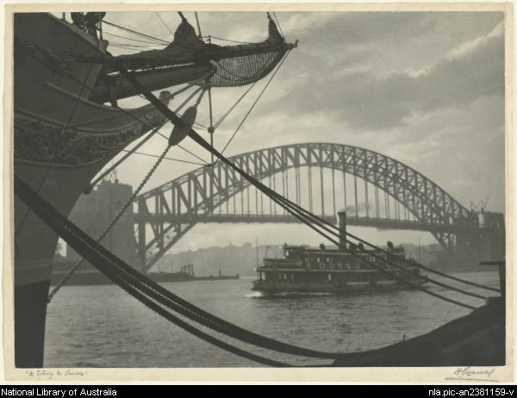

Harold Cazneaux, *A Study in Curves*, 1931, silver gelatin photograph, 26.9 x 37.3 cm, Collection: National Library of Australia (http://nla.gov.au/nla.pic-an2381159)

The groundwork for modernist photography was laid in the 1920s by photographers such as Cecil Bostock and Harold Cazneaux in Sydney. Bostock experimented with abstract and reductive compositions and Cazneaux turned his camera on to the urban world around him, especially in the work he undertook for the influential magazine *The Home*. While Cazneaux is often recognised as the progenitor of modernist photography his approach was in fact modulated by his Pictoralist origins and his images were generally softer in affect than the first generation modernists who came after him: Max Dupain, Laurence Le Guay, Axel Poignant and Athol Shmith.

International modernism – especially in the USSR and Germany – was tied to revolutionary politics but in Australia this was not the case. Australian exponents wished to overthrow what they saw as outmoded forms of expression rather than a repressive or conservative political regime. They therefore campaigned against the highly aestheticized Pictorialist style and its ‘olde worlde’ associations.

In terms of geography the practice of modernist photography was unusually concentrated, with Sydney being the centre during the 1930s and the Max Dupain studio (established 1934) widely recognized as the leader in the field. Dupain was well informed about developments overseas through purchases of German and American photography magazines, and reviewed a book on Man Ray’s photography for *The Home* in 1935. International visitors to Australia were few – George Hoyningen-Huene and E. O. Hoppé being exceptions – but Australians were in dialogue with their international counterparts through inclusion in high-profile exhibitions and publications. Olive Cotton was not alone in considering her selection for London Salon of Photography exhibitions as the pinnacle of artistic achievement.

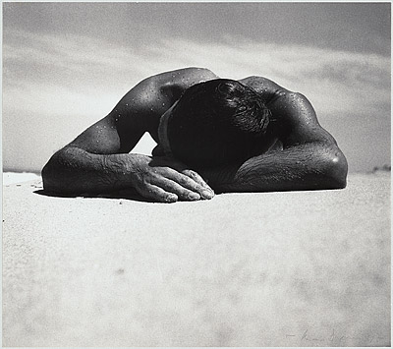

Max Dupain, *Sunbaker*, 1937, silver gelatin photograph, 38.6 x 43.4 cm, Collection: National Gallery Australia, Accession No. NGA 76.54 (http://artsearch.nga.gov.au/Detail.cfm?IRN=102513)

In the early modernist period women practitioners became more prominent, conspicuous examples being Ruth Hollick, May and Mina Moore and Cotton, but the professional and artistic spheres continued to be dominated by men. In some studios the roles were sharply defined according to gender, with the men being the camera operators and the women involved in retouching and hand-colouring and administration of the businesses.

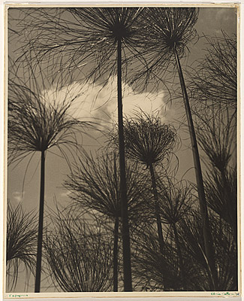

Olive Cotton, *Papyrus*, 1938, silver gelatin photograph, 26.8 x 30.8 cm, Collection: National Gallery Australia, Accession No. NGA 87.1440 (http://artsearch.nga.gov.au/Detail.cfm?IRN=72418)

In their art photography Australian modernists did not confine themselves to urban subject matter or still lives. As with the Pictorialists, the landscape genre proved crucial, with the ‘bush’ being represented as a source of replenishment and an antidote to the fast pace and rapidly changing nature of modern city life. The engagement with landscape reflected some ambivalence about the benefits of modernity and progress. In the 1930s the beach appeared as a new arena for human action in images by Dupain and others that celebrated the physicality of Australians. The production of nude figure studies was related to this interest in body-culture.

The progressive, experimental aspects of the first phase of modernism were evident in the adoption of different techniques and processes and a brief flirtation with Surrealism. A small number of photographers worked with solarisations, photomontages and created abstract compositions. However, the outbreak of the Second World War and associated cultural change brought an end to any significant degree of experimentation. Photographers began to be dispersed, contributing in different ways to the war effort: Edward Cranstone and Geoffrey Powell were among those who made documentary photographs for the federal government’s Department of Information.

Modernist practice, which was always closely aligned with the commercial world and the opportunities advertising presented, was reshaped after the war as a number of influential European émigrés began to be active. They included Helmut Newton and Wolfgang Sievers, both from Berlin, who worked in the fields of fashion and industry respectively. In contrast to most locally trained photographers, émigrés did not generally make a distinction between their commercial and personal or exhibition work. Other important European-born photographers were Margaret Michaelis who worked mainly in portraiture during the 1940s, and Richard Woldendorp who established his reputation with aerial views of the Australian landscape.

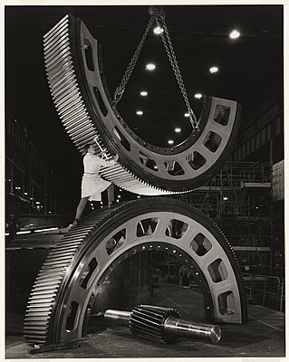

Wolfgang Sievers, *Gears for Mining Industry*, *Vickers-Ruwolt, Melbourne*, 1967, 50.7 x 39.7 cm, Collection: National Gallery Australia, Accession No. NGA 82.2210 (http://artsearch.nga.gov.au/Detail.cfm?IRN=89313)

In the 1950s documentary and other forms of straight photography remained dominant. The emphasis was on the external world coinciding with a period of economic growth and prosperity. Architectural and industrial photography reflected this orientation. Photojournalism also flourished with David Moore securing an international reputation as a photojournalist; his images were published in magazines such as *Time-Life*. He and Laurence Le Guay were included in the influential *Family of Man* exhibition which toured to Australia from the Museum of Modern Art, New York in 1959.

Modernist photography in Australia remained a coherent and vibrant form until the late 1960s when a whole cluster of new approaches began to be evident. These were linked to the explosion of art photography and the emergence of practitioners who defined themselves as artists rather than professional or commercial photographers. A significant number of photographers whose practice was formed in the heyday of modernism successfully made the transition to the world of art photography.

**References and Further Reading**

Batchen, G. (2001) *Each Wild Idea: Writing, Photography, History*, Caimbridge: MIT press.

Butler, R. (1997) *The Europeans: Émigré artists in Australia 19*30-1960, Canberra: National Gallery Australia.

Crombie, I. (2004) *Bodyculture. Max Dupain, photography and Australian Culture, 1919-1939,* Melbourne:Images Publishing in association with National Gallery of Victoria.

Ennis, H. (2007) *Photography and Australia*, London: Reaktion Books.

Newton, G., with essays by H. Ennis and C. Long. (1988) *Shades of Light: Photography and Australia 1839-1988,* Canberra: Australian National Gallery, Collins Australia, 1988.

Willis, A-M. (1988) *Picturing Australia: A History of Photography*,North Ryde, NSW: Allen & Unwin.